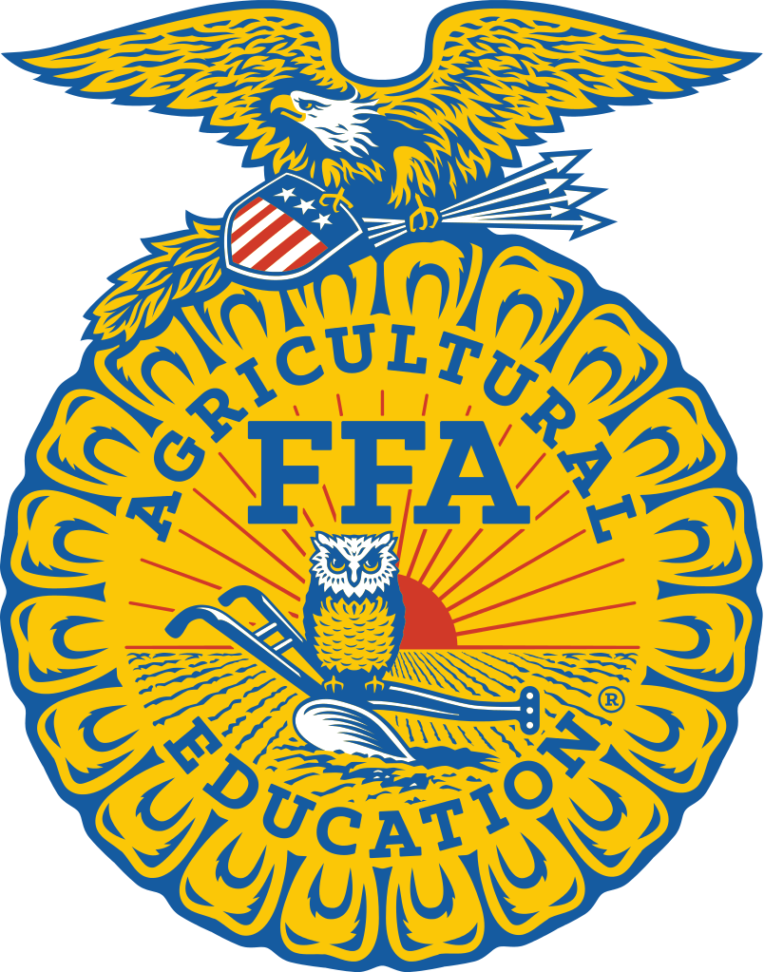
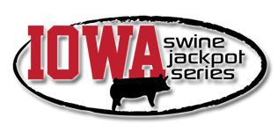
Oskaloosa FFA Spring Jackpot
Saturday May 28th, 2016 Contact information: Bret Spurgin 641­895­2291
spurginb@oskycsd.org Southern Iowa Fairgrounds 615 N I Street
Oskaloosa, IA 52577 Judge: Charlie Fitzgerald

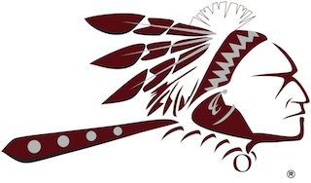
*All pig classes & showmanship classes will be divided in accordance with ISJS guidelines
*Check ins from 7:30­9:30 AM
*Showmanship starting 30 Minutes after Agri­Power Prospect Market Pig Sho
*Registration papers required for all purebreds
*Health papers required
*Shavings only (bring your own)
*Concessions available

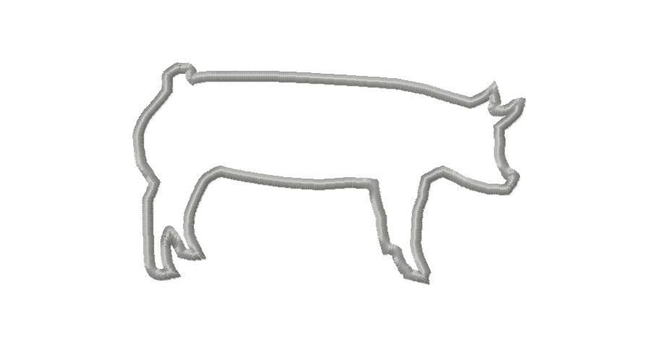
Entry Fee: $20/head Awards:
Champion ­ $250 and Banner Reserve ­ $200 and Banner 3rd Overall ­ $150 and Banner 4th Overall ­ $100
5th Overall ­ $50

•Non­Terminal Show. All animals released after the show • Iowa Swine: Need a Certificate of Veterinary Inspection issued by a Certified Iowa Veterinarian • Out of State Swine: Must present test record and Certificate of Veterinary Inspection •Bring your own bedding. No straw in the barn • Purebred Classes will be offered • Purebreds must present pedigree papers at weigh­in • Crossbred barrows and gilts will be shown by light cross and dark cross colors • There is no minimum or maximum weight limit for the show • Showmanship will be broken down into the following divisions: Junior: Ages 3­15 Senior: Ages 16 and Older •

